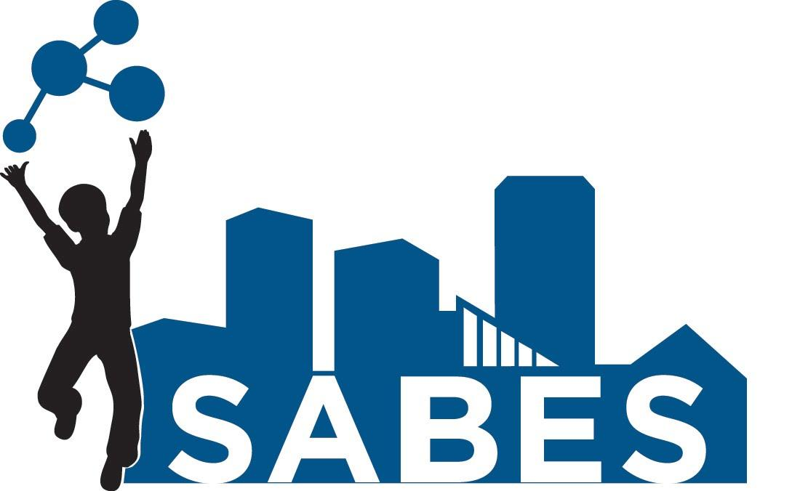

Life Science STEM Academy Syllabus
Tuesday, 5:00-7:30pm

Instructors: Melissa Garcia, Kevin Okun, Keyshawn Boss
Instructional Support: Sandra Strittmatter, David McKinney.
Location: JHU School of Education, 2800 N. Charles St., Room 216
Email: magarcia@bcps.k12.md.us; kgokun@bcps.k12.md.us; knjenkins@bcps.k12.md.us

Description: This course is designed as an introduction to life science concepts addressed in the Next Generation Science Standards. Topics will include: Matter and Energy in living systems; Heredity; Evolution and Natural Selection; and Application of Life Sciences in Engineering. This course is designed to deepen understanding of life science to increase your confidence in teaching this content through inquiry-based instruction.

Objectives:
- Learn life science content knowledge and related pedagogic skills to improve student learning and achievement
- Apply newly acquired content knowledge to correct common student misconceptions and other learning activities
- Identify, analyze, and reflect on issues in science teaching and learning
- Practice hands-on, inquiry-based learning and learn implementation approaches for particular classroom settings
- Develop an understanding of science content, pedagogy, and science and engineering practices necessary for the successful implementation of the STEM curriculum
- Become reflective practitioners in science

Materials
Edmodo account
Any materials requested before the session

Attendance Policy
Participants are expected to arrive on time and to participate in all classes as scheduled. If a participant is absent from a class session, she/he is still responsible for completing the class work and homework assigned for every session. Participants can only miss five hours of instruction total, the equivalent of two class sessions. For participants who arrive late, the amount of time missed, rounded up to the nearest half hour, will be included in their missed session time.

Participation
During each class, each participant will be issued a “participation grade” based on his/her engagement in the work. This means that participants should be on task at all times, and all side conversations and use of technology (i.e. cell phones/tablets) should be at a minimum, or not occur at all.

Assignments
Homework
- Pre-session - assignments to prepare you for the upcoming session’s content
- Post-session - assignments to evaluate learning
All assignments will be graded as satisfactory or unsatisfactory. Participants must earn satisfactory on all assignments to receive course credit. Assignments that are unsatisfactory can be resubmitted once.

Three AUs and three CPD MSDEs will be awarded for the successful completion of the course; ‘successful completion’ will be evaluated based on session attendance, assignment grades, and participation grades.

Statement of Academic Continuity: Please note that in the event of weather and/or in other extraordinary circumstances, the School of
Education may change the normal academic schedule and/or make appropriate changes to course structure, format, and delivery. In the event such changes become necessary, information will be posted on the Edmodo site.

Topics:

Session # | Date | Topic | NGSS  (Disciplinary Core Ideas)
1 | Sept 20 | Introduction/ Energy in biological systems | LS1.C  LS2.B  PS3.D
2 | Oct 4 | Photosynthesis & Cellular Respiration | LS1.A  LS1.C  PS3.D
3 | Oct  18 | Matter and Energy in biological systems - Forms and Transfer | LS1.C  LS2.B  PS3.D
4 | Nov 1 | Food Chains/Webs | LS1.C  LS2.A  LS2.B  LS2.C
5 | Nov 15 | Energy Pyramids | LS1.C  LS2.A  LS2.B  LS2.C
6 | Nov 29 | DNA and Protein Synthesis | LS1.A  LS1.B  LS3.A
7 | Dec 13 | Inheritances of Traits | LS3.A  LS3.B  LS4.A
8 | Jan 10 | Natural Selection | LS4.B
9 | Jan 31 | Structures/Functions of Traits | LS1.A  LS4.B  LS4.C

Session # | Date | Topic | NGSS  (Disciplinary Core Ideas)
10 | Feb 21 | Adaptations | LS4.C  LS4.D
11 | Mar 7 | Evidence of Evolution | LS4.B  LS4.C
12 | March 21 | Biomimicry | LS1.A  LS4.C  ETS.1-1  ETS.1-2  ETS.1-3  ETS.1-4

****Snow Dates: March 28, 2017 and April 4, 2017

