2012 City Schools Sustainability Challenge Report Form
Thank you for your participation in this year’s City Schools Sustainability Challenge! We are extremely excited about the work you are doing and would like to know more. This information is required for us to report to our funders and improve the way we work with city schools on sustainability in the future. Please be complete but to the point in your answers. The report is due by Wednesday, May 30, 2012, but you are welcome to submit it before then. If you have any questions, please contact Josh Medina at joshua.medina@baltimorecity.gov or 410-396-5917. Your completed form should be sent to Josh either by email, fax (410-244-7358), or mail (Office of Sustainability, Josh Medina, 417 E. Fayette St., 8th floor, Baltimore, MD 21202).
1) Please describe, in 1-2 concise paragraphs, the results of your 2012 City Schools Sustainability Challenge project. Please feel free, also, to attach any additional documentation related to your project such as newsletter articles, flyers, etc.
With this grant we set out to improve our waste reduction at Federal Hill Preparatory School. Before receiving this grant we used Styrofoam trays to carry our lunches to our tables. These Styrofoam trays accounted for 2/3 of our waste. We serve 200 lunches in our cafeteria per day. That’s 1000 trays per week that we throw in the trash!
Once we started using compostable trays, we reduced our trash by 2/3. We had to get another food waste bin to collect our organic waste. We doubled the amount of compostable material collected. The kids were able to see a tremendous difference in the amount of waste they were able to divert from the landfill. Showing the students how they can recycle their waste will go a long way to improving the planet for future generations.
2) Please attach 2 or more pictures or videos related to your project.
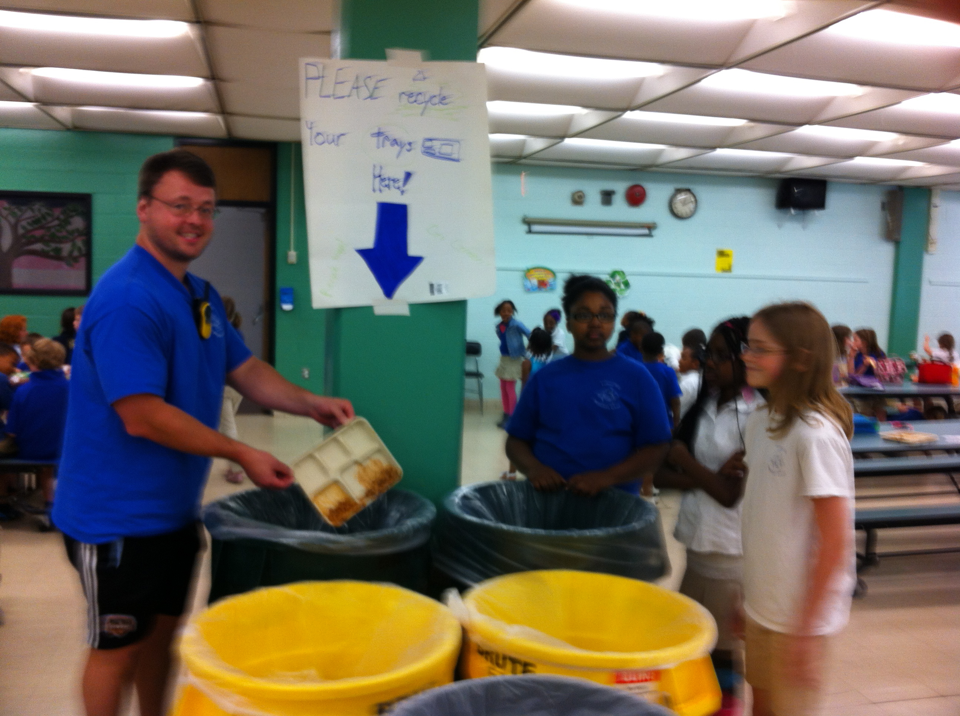
Photos attached
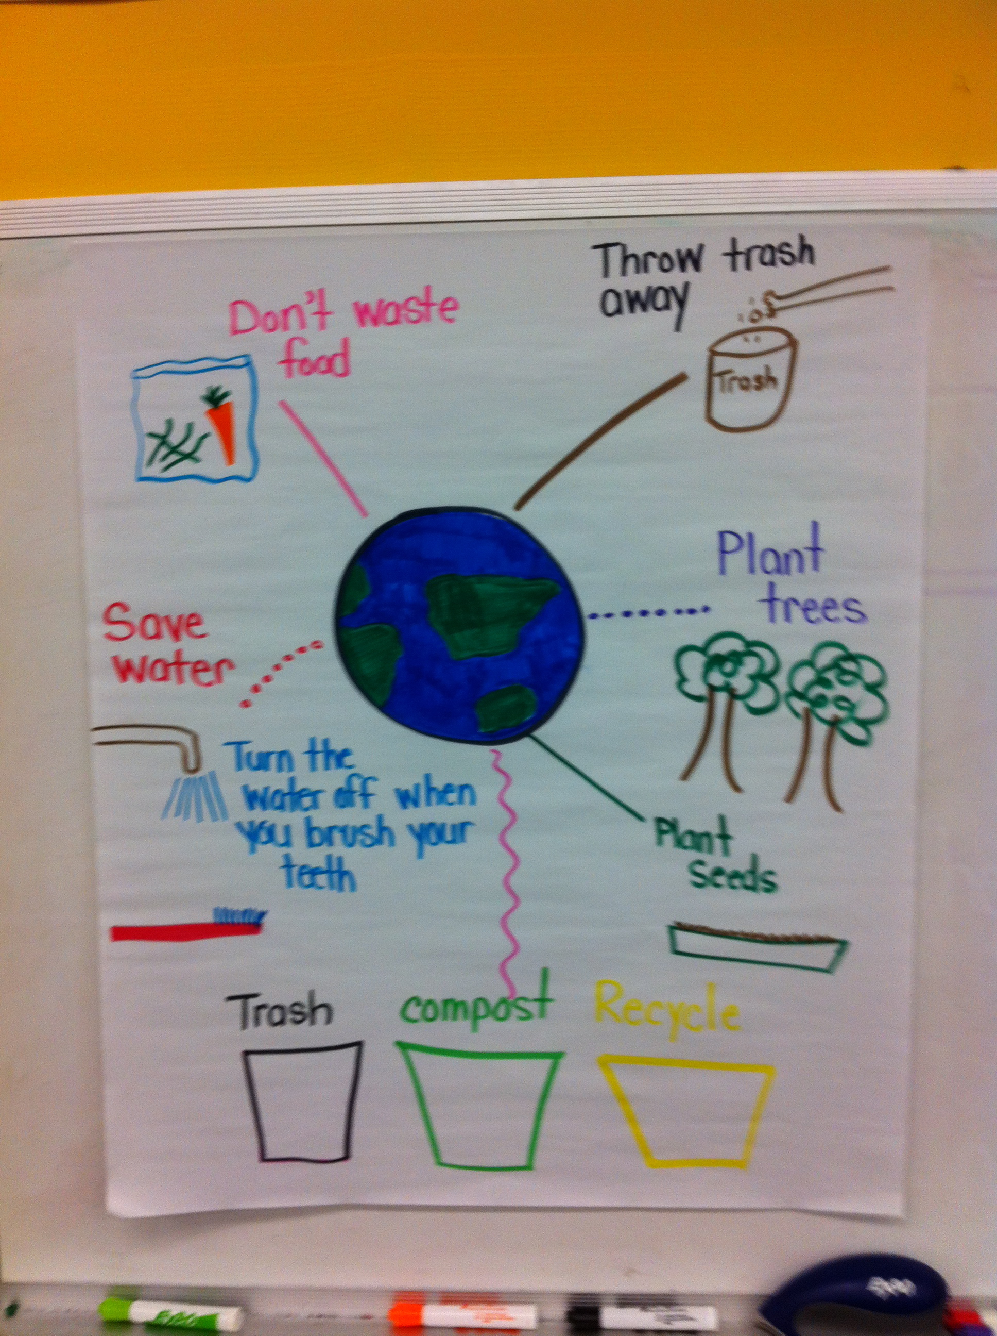
3) Was the money for the project spent as planned? If your budget changed, please describe why and how the funds were spent. Please attach copies of receipts.
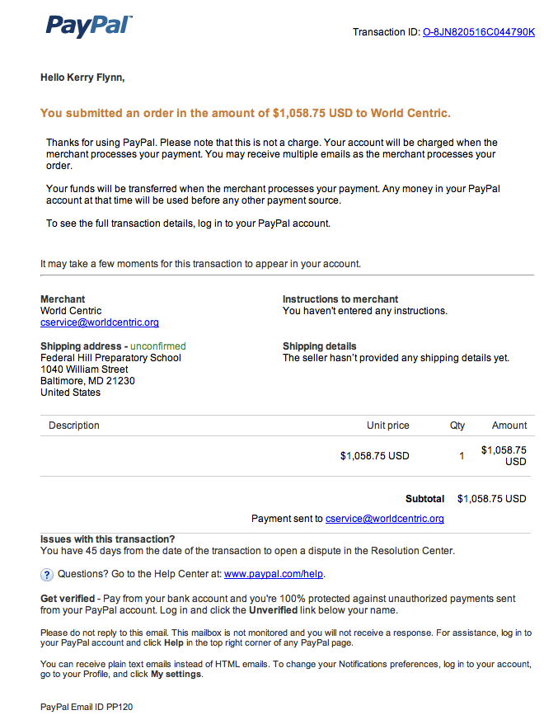Yes, money was used as planned.
4) Please list any partners that helped with your project and if possible include their contact information.
PTO with parent volunteers and additional money to cover extra cost of compostable trays
5) What was the high point of your project for the student team members?
The highest point for the student team members was when they (the fifth grade class) went to the Masonville Cove for a year end festival and we were able to bring back 4 bags of compostable lunch waste with us. We were proud to be recognized as a school that recycles and composts.
6) What, if any, lasting benefits do you think your school will see from this project?
7) What would you change about your execution of the project, if you could go back?
If we were to start this project over again, I would start with a meeting with the cafeteria staff, a representative from North Ave and a member of the Office of Sustainability, to discuss and outline the responsibility of simply taking the contents of the 3 separate bins to their outside containers.
8) What would you change about the grant award process for next year?
We didn’t have any issues with the grant award process.
9) How many students were involved in planning and/or implementing the project? How many, if any, additional students were reached by the project? If additional students were reached, please explain how (i.e. assembly, posters, etc.).
10 Fifth graders. The rest of the school population was reached during this project. They were all able to use the compostable trays during lunch and were able to see how much more waste was diverted from the trash and therefore the landfill.
10) Please quantify any other accomplishments associated with your project (i.e. # of recycling bins distributed, # of garden beds installed, # of CFL light bulbs installed, etc.).
Once we began using the compostable trays, we went from needing 3 food waster toters to 5 toters, which we filled weekly. Photo attached
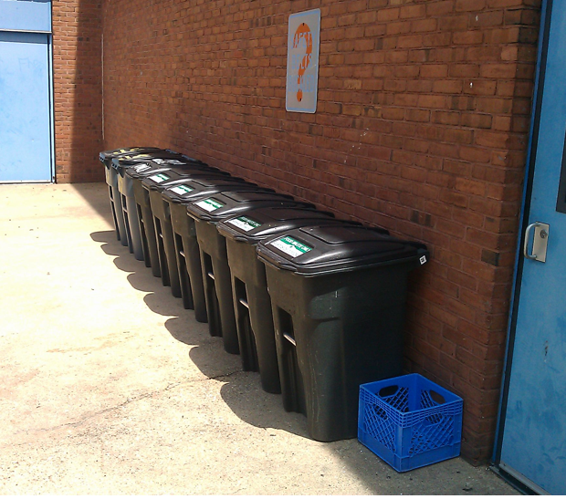
11) If possible, please share a quote from one or two of your student team members about the project (please include the student’s name).
"This project impacted me because now everytime I got to McDonalds, I don't get a cup holder because it's just going in the trash". Sydney R. age 10
"Composting helped me understand why it's better for the environment. Less trash, means less in the land fill" Orianna B. age 11
12) Is your school is not currently a certified Maryland Green School with the Maryland Association for Environmental and Outdoor Education, are you working towards certification? If not, are you interested in beginning this process?
Yes, we are currently working on a 2 year trajectory towards becoming a certified green school.
13) Did your school work with the Baltimore Energy Challenge in spring 2012? If so, please describe any benefits to your project or to your school’s sustainability efforts.
Yes, the students put "Please Turn it OFF" stickers on all the light switches and meet with the evening custodial staff to turn off the lights when they are finished working in a room. Now, the school is dark at night, except for the necessary safety lights.
14) Is there anything else that you’d like to share about sustainability for your school or the city school system in general – questions, comments, concerns, requests?
In order for composting to work in our schools, we need more support from our custodial staff. The way our school lunches are packaged is a problem as well. The ketchup packets, the plastic bagged sandwiches and the plastic bagged spork, napkin, straw combo all hinder our composting efforts.

